**ARC-GIS**

**EXCERCISE: 3**



BY – AMANUEL LEGESSE SOFTWARE ENG. EXT

ID – ATE/3628/11

**Projecting spatial datasets**

**1.A:**

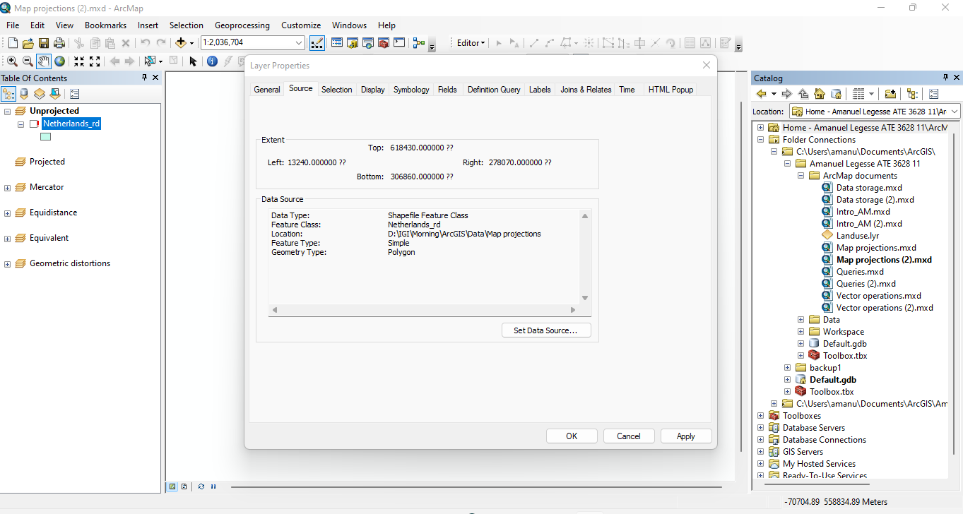

**1.B:**

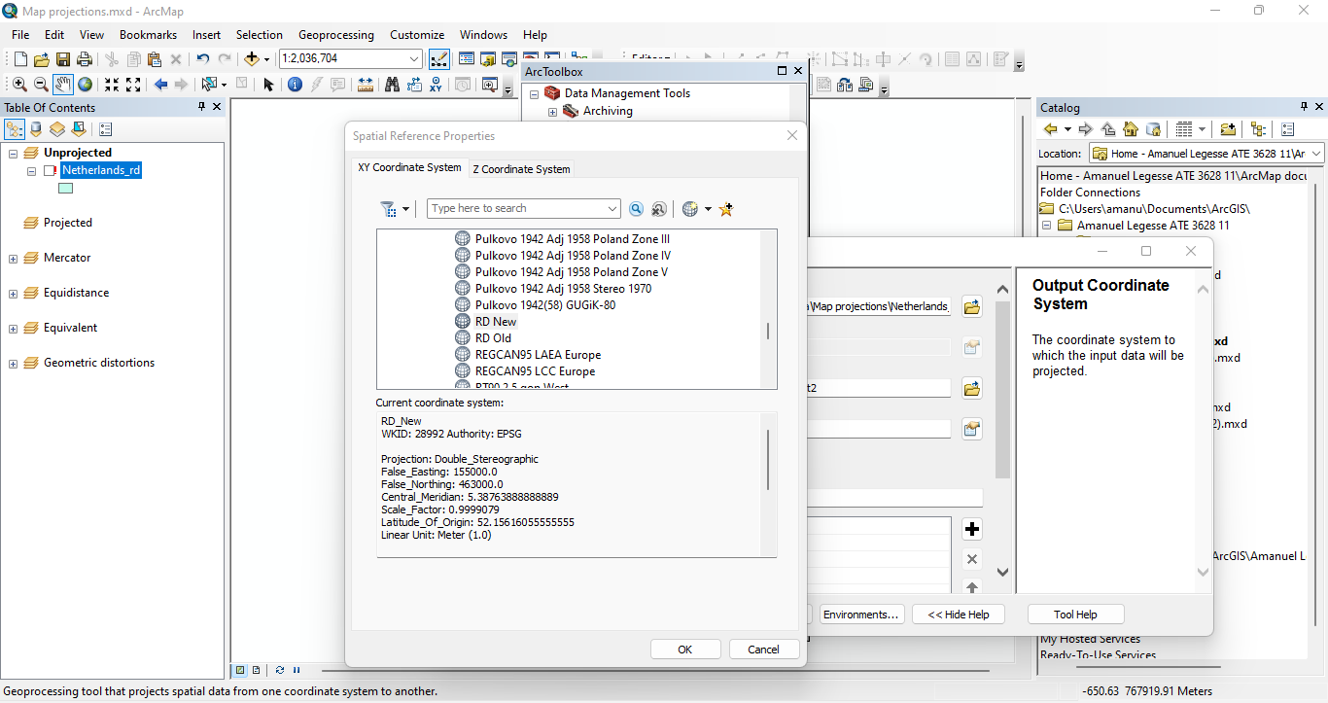

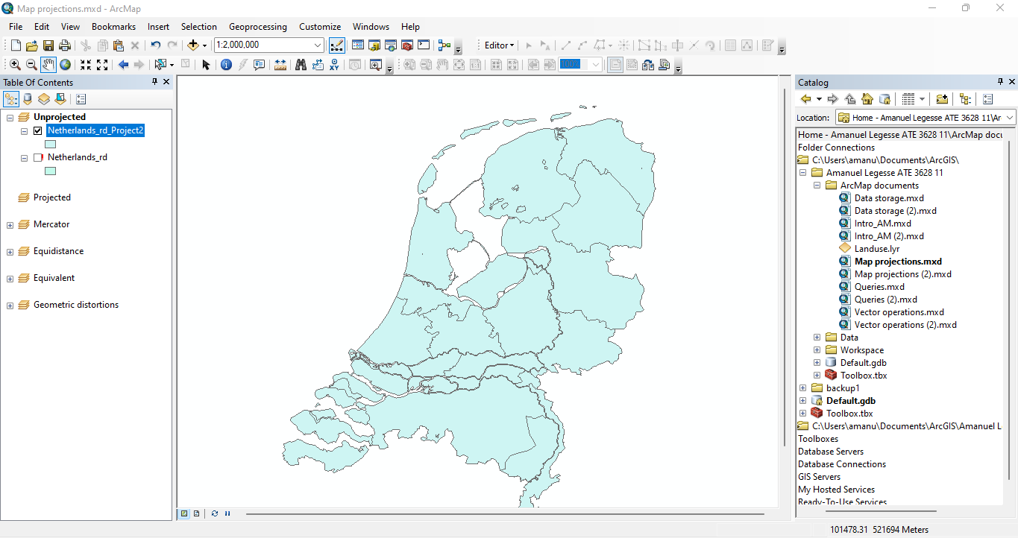

**1.C:** The projection is coordinate system based

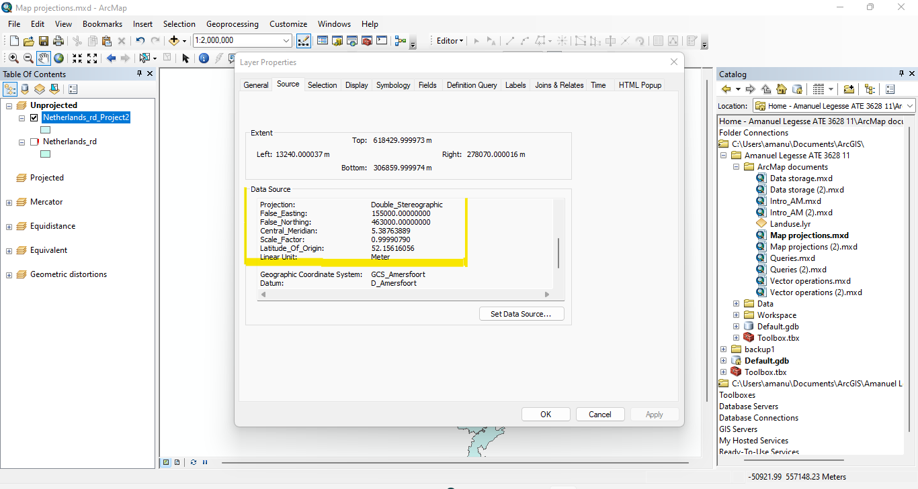

**1.D:**  The Linear unit is in Meter.

**Reprojecting spatial datasets**

**2.A:**

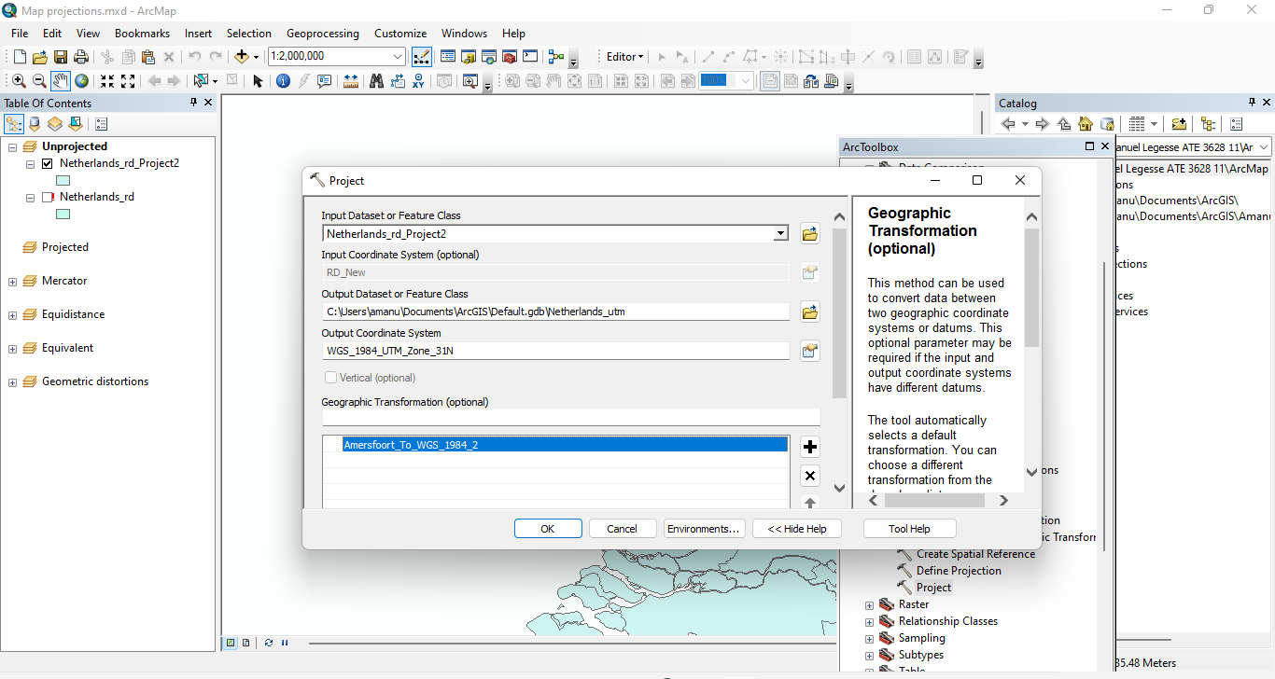

**2.B:**

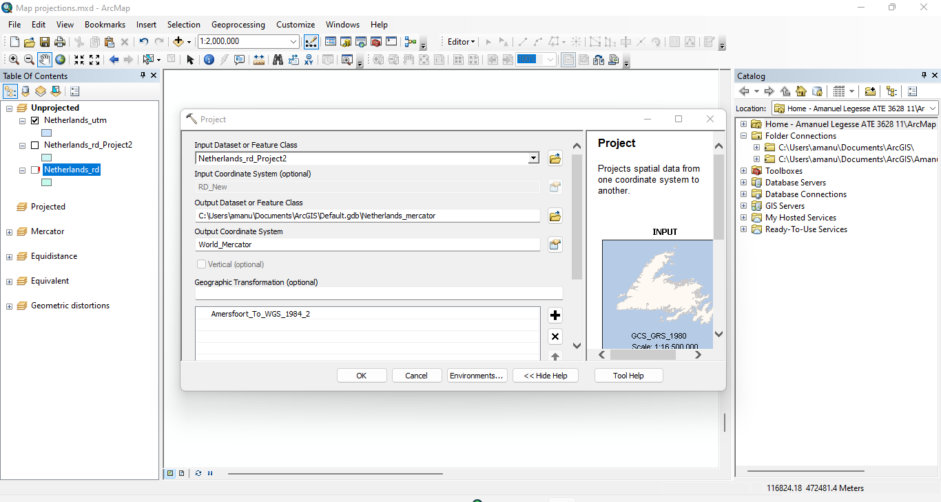

**2.C:** The three datasets don’t overlap because of their map projection towards the coordinate system placing each dataset in different parts of the world

(Example map projection UTM was placed in the Northern Hemisphere).

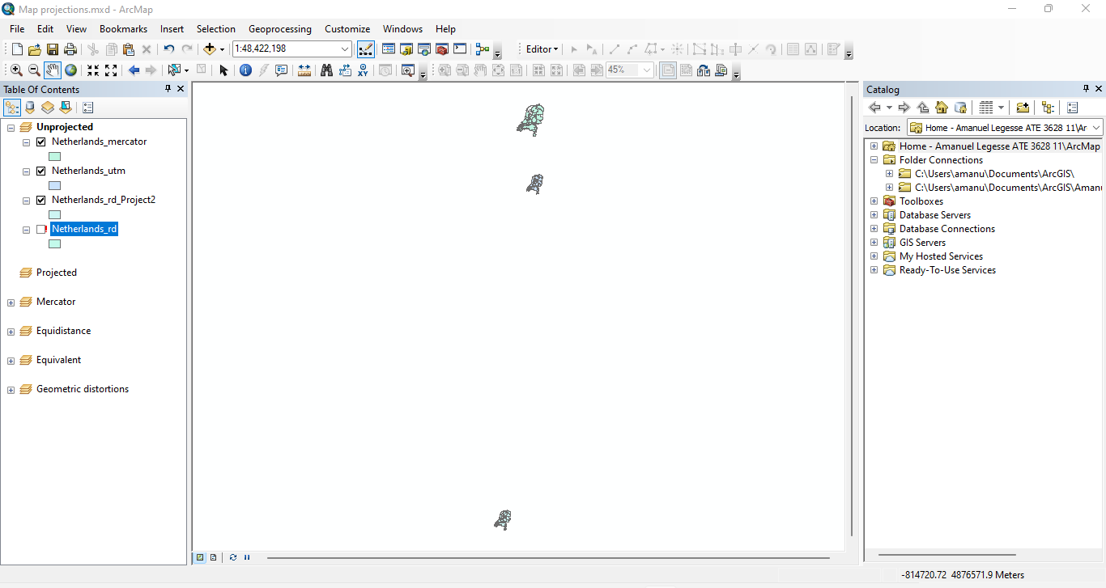

**Projection of the Data Frame**

**3.A:** As seen below after the projection of the Data Frame was changed to ‘RD New’ the map becomes in full view and clear.

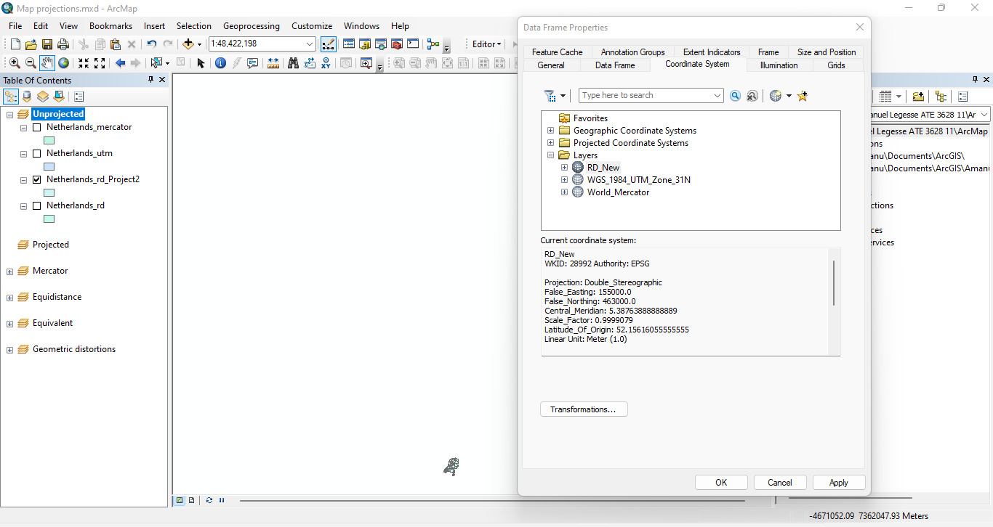

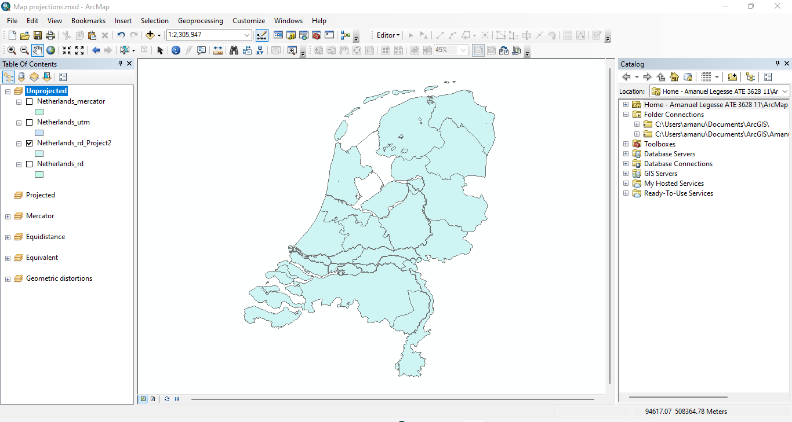

**3.B:** The is no coordinate system.

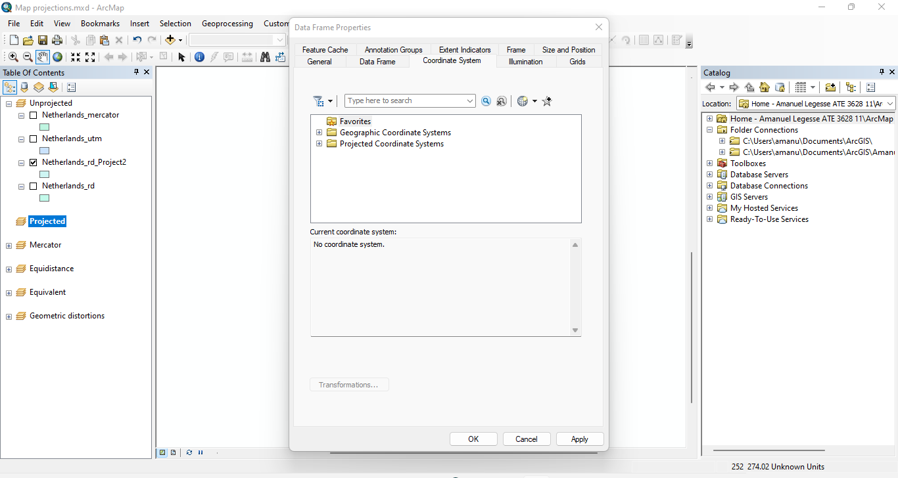

**3.C:**

* Projected Coordinate System: World_Mercator
* Projection: Mercator
* Geographic Coordinate System: GCS_WGS_1984

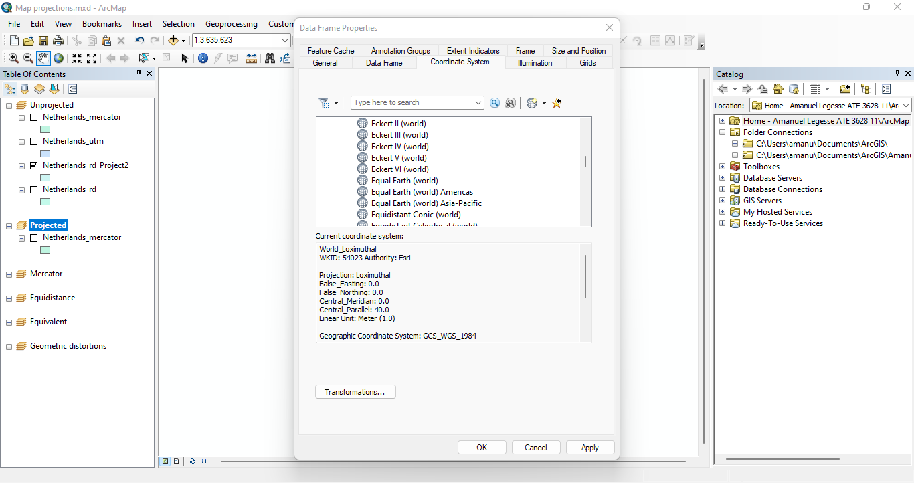

**3.D:**

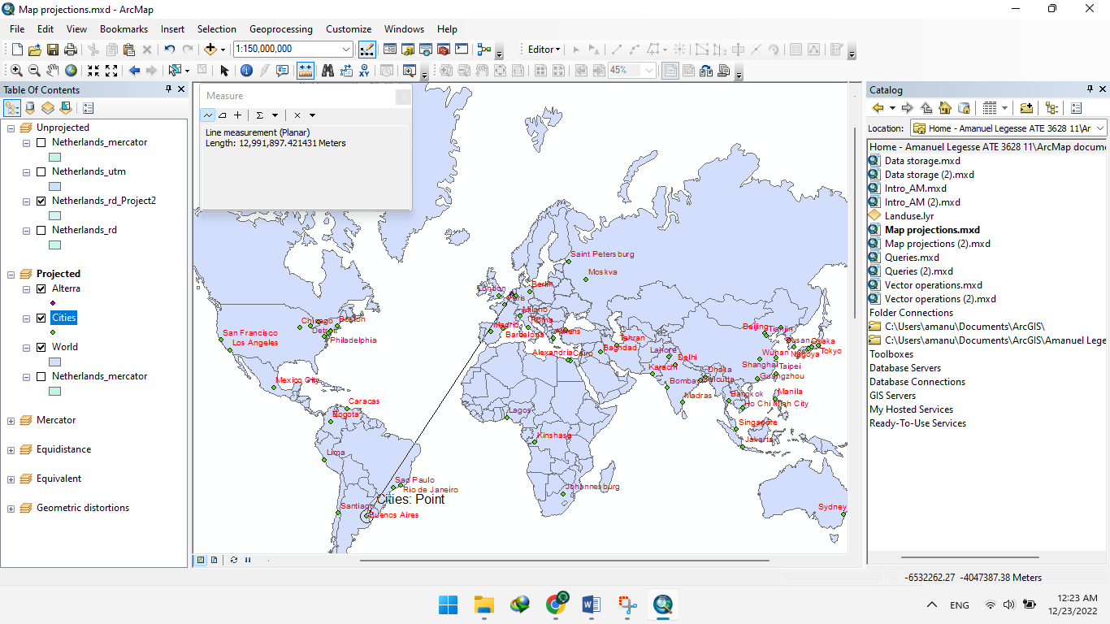

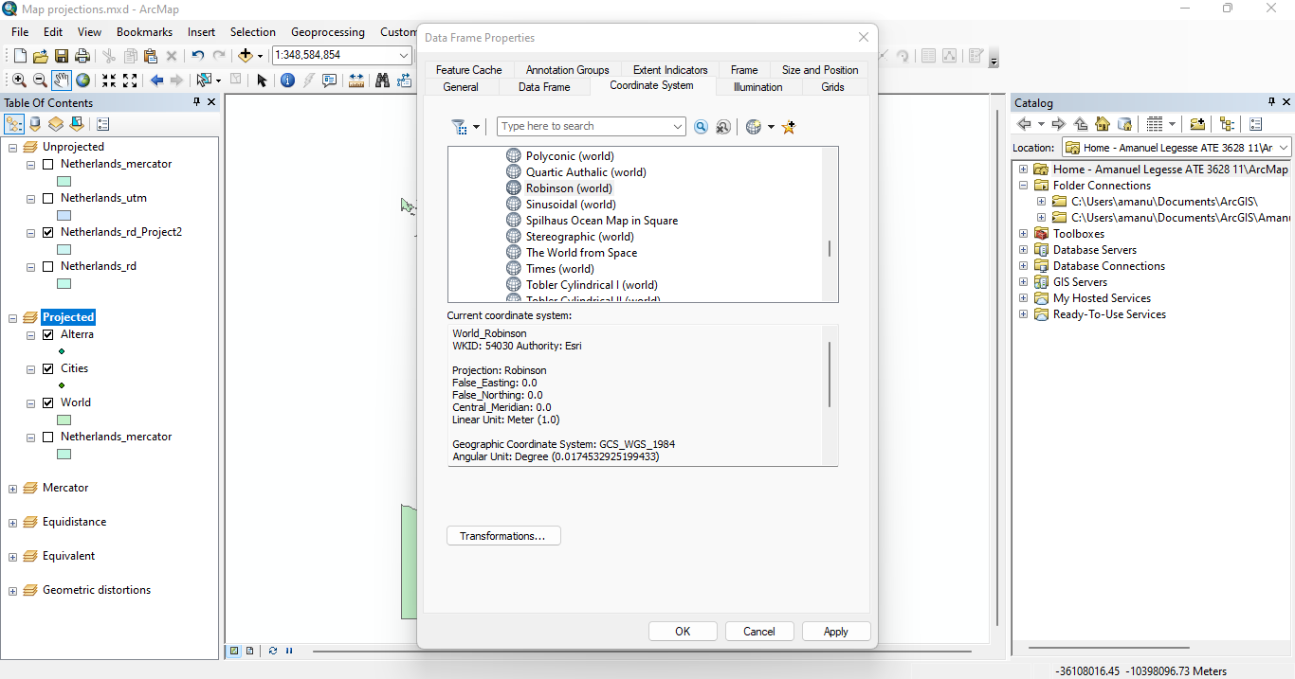

* Yes the distance differ from the previous measurement because the projected coordinate system was changed to Robinson.

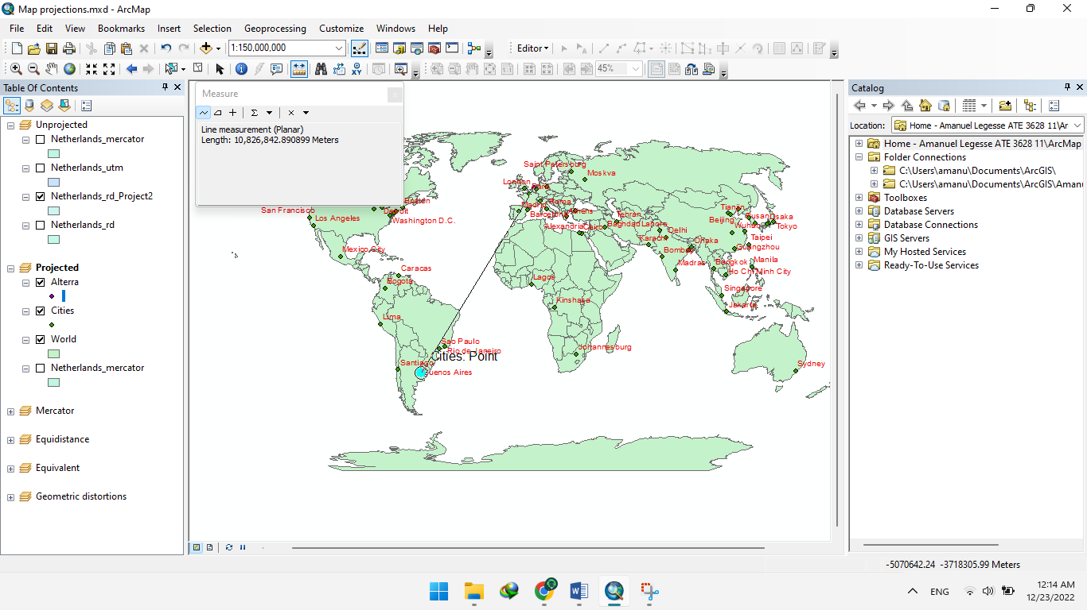

**Geometric distortions**

**4.A: Mercator**

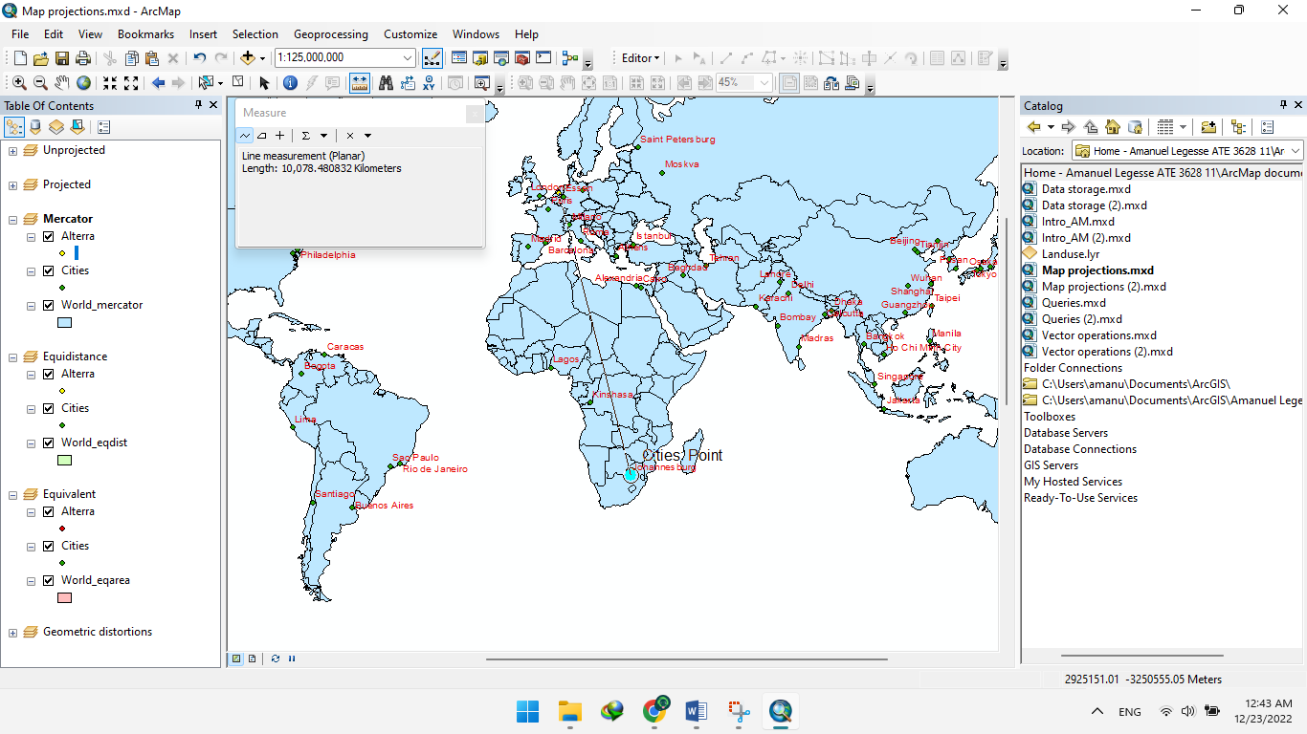

**Figure:** Alterra – Johannesburg (km)

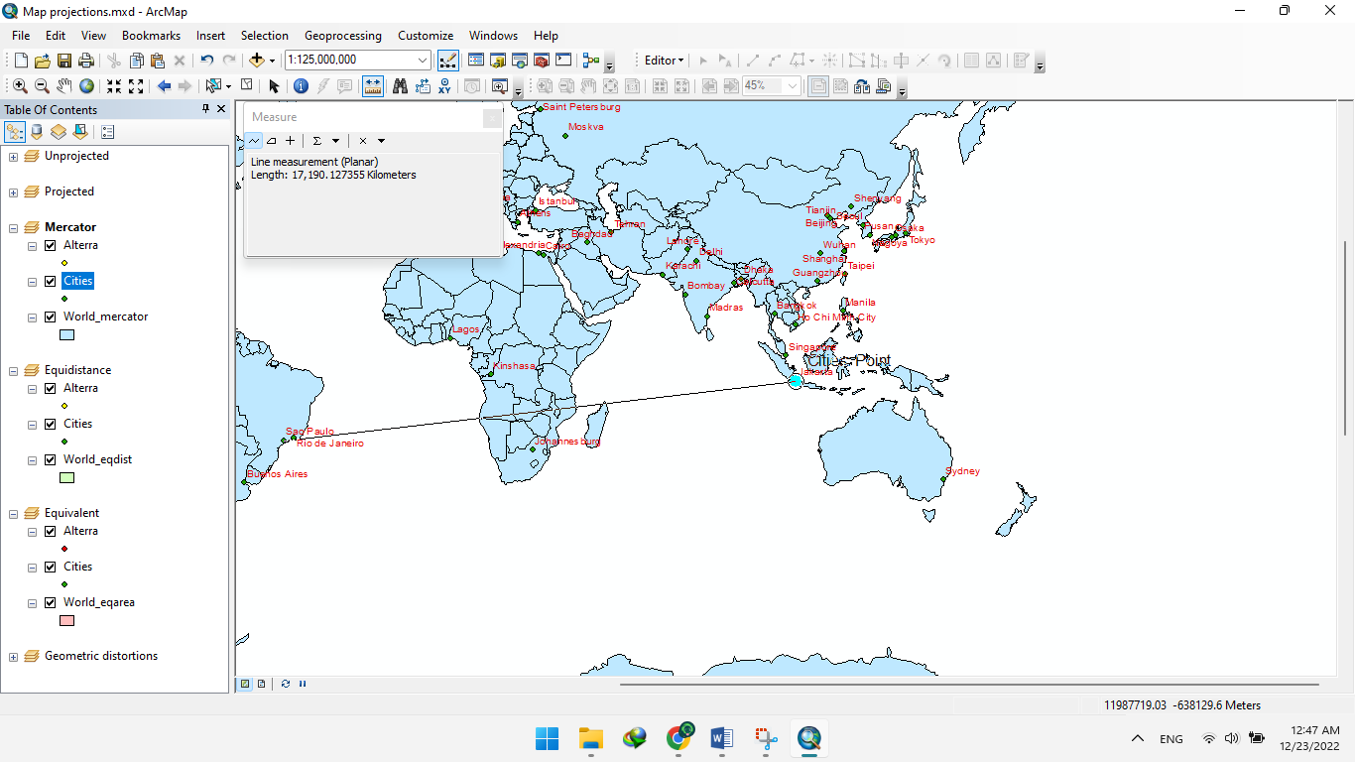

**Figure:** São Paulo – Jakarta (km)

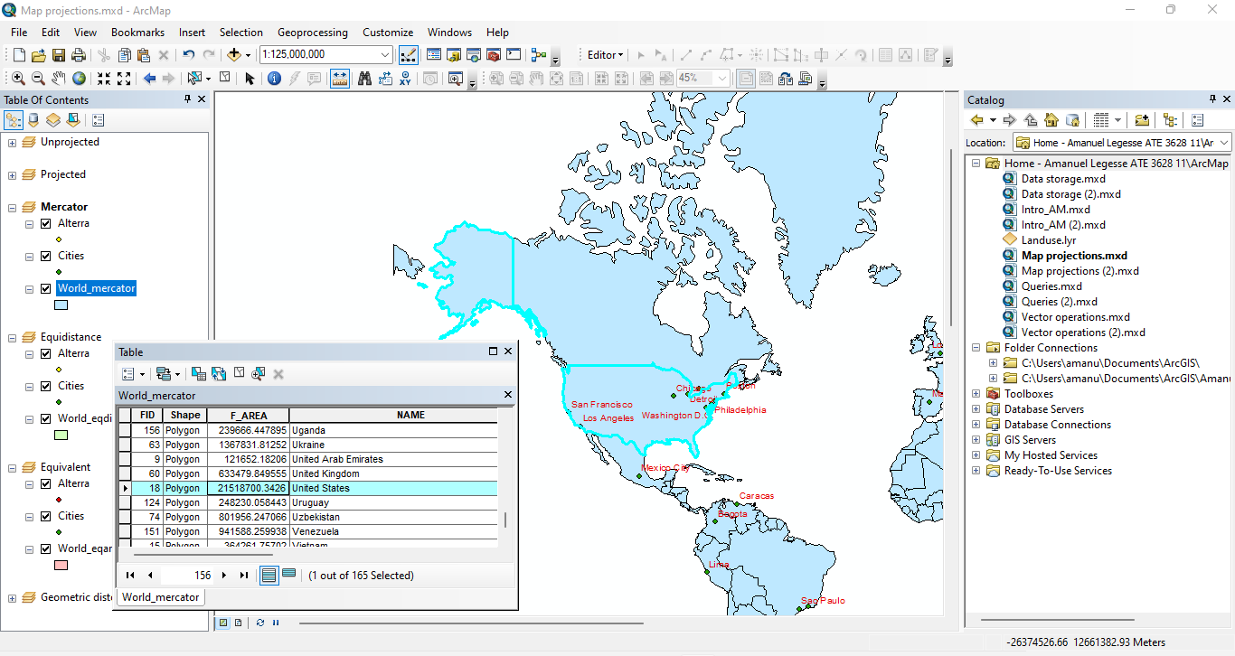

**Figure:** Area USA (km²)

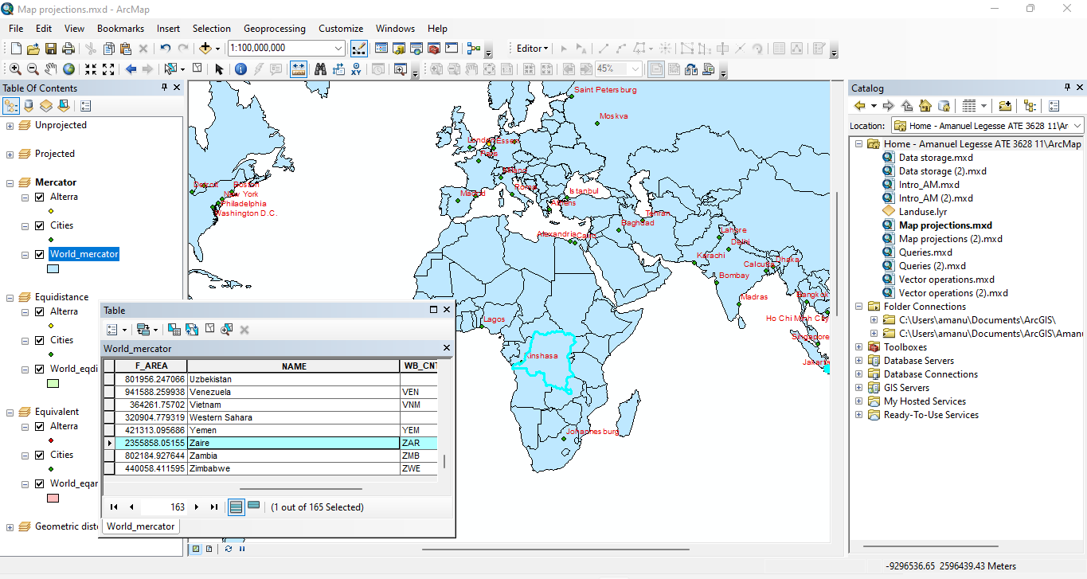

**Figure:** Area Dem. Rep. Congo (km²)

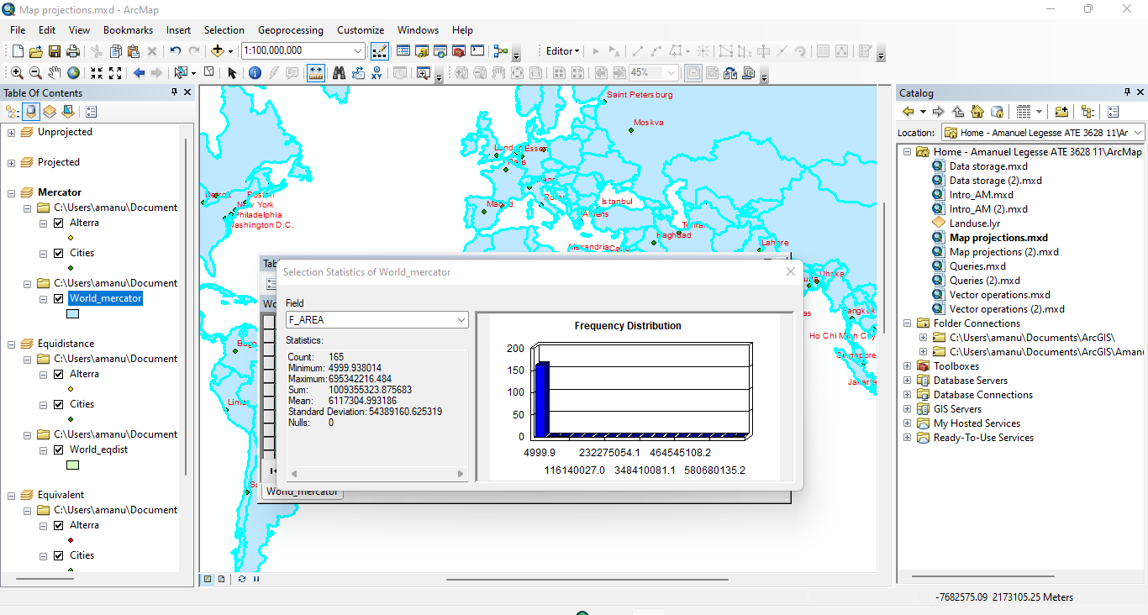

**Figure:** Area World (km²)

**4.B: Equidistant**

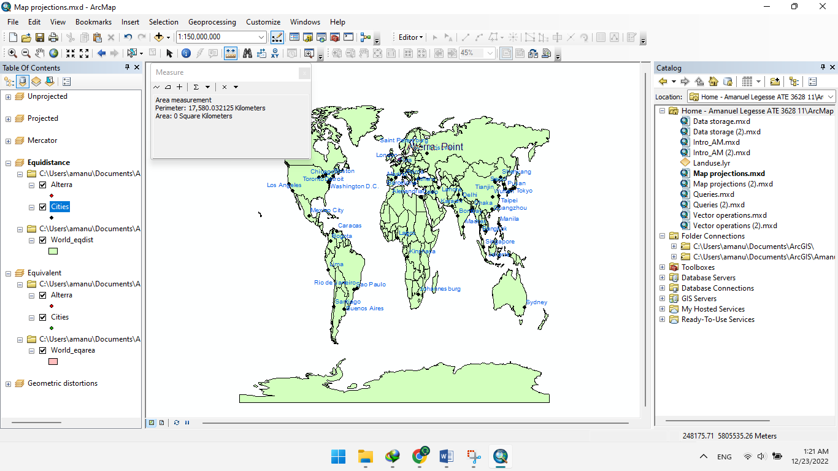

**Figure:** Alterra – Johannesburg (km)

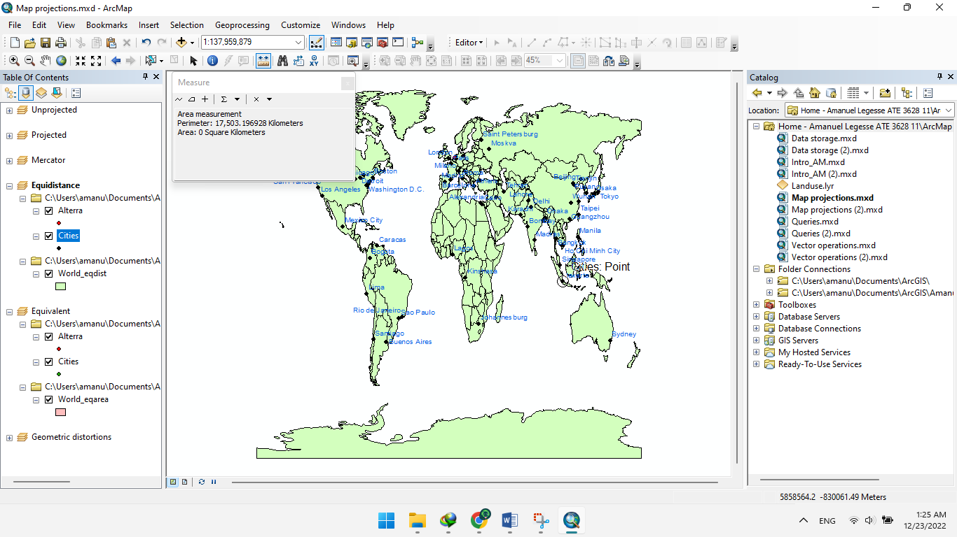

**Figure:** São Paulo – Jakarta (km)

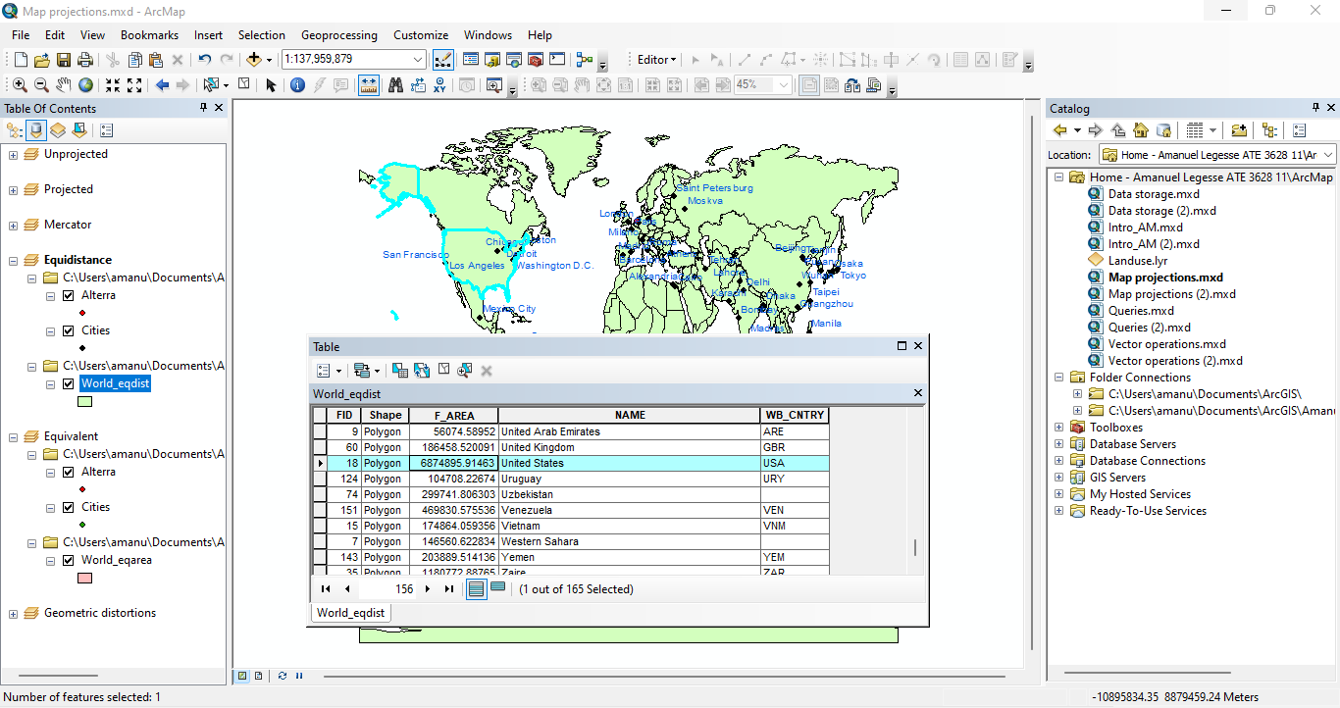

**Figure:** Area USA (km²)

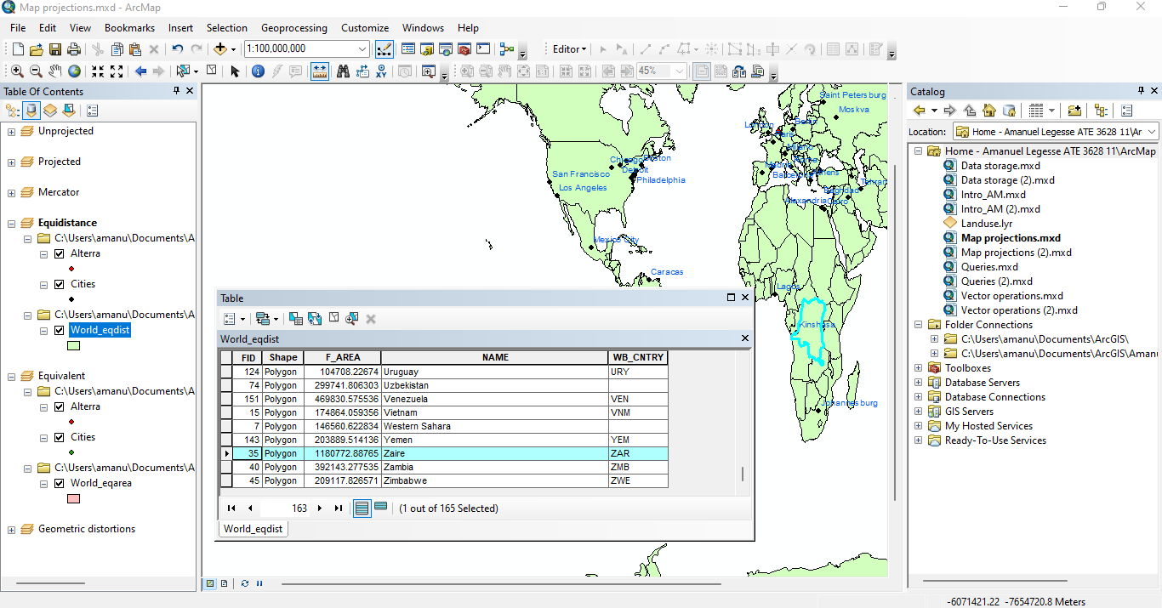

**Figure:** Area Dem. Rep. Congo (km²)

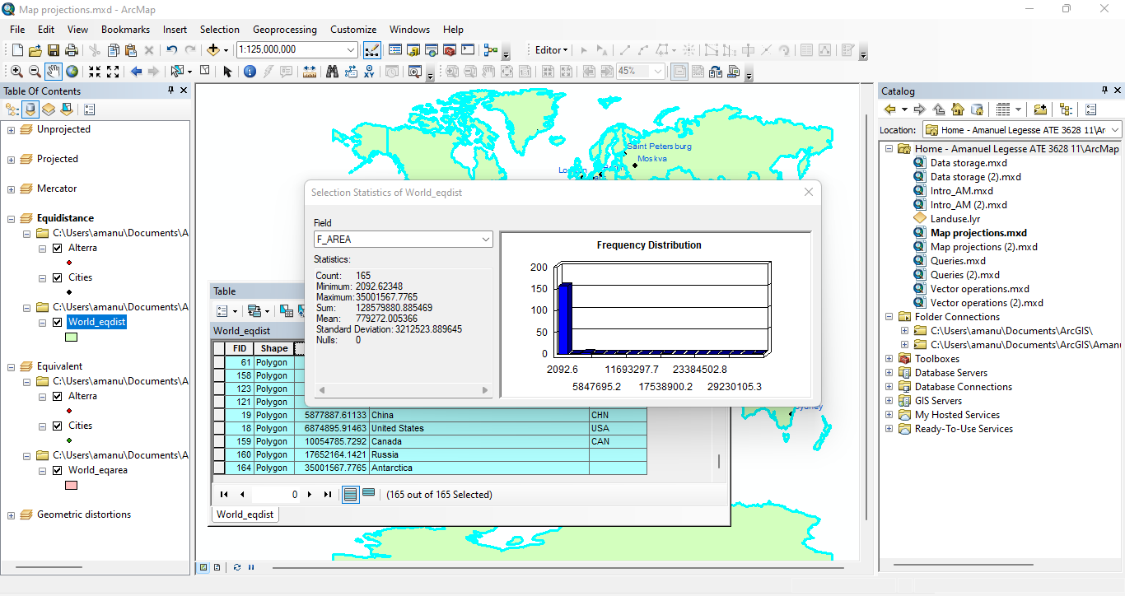

**Figure:** Area World (km²)

**4.C: Equivalent**

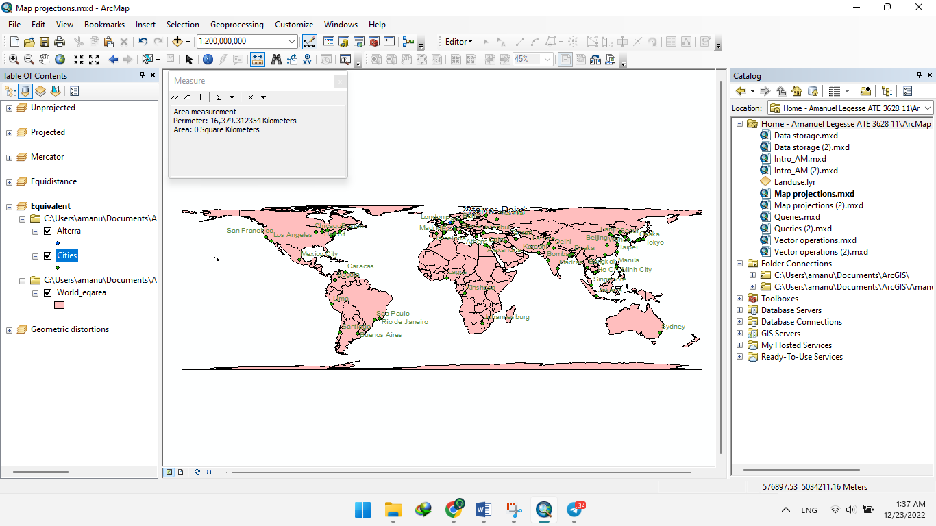

**Figure:** Alterra – Johannesburg (km)

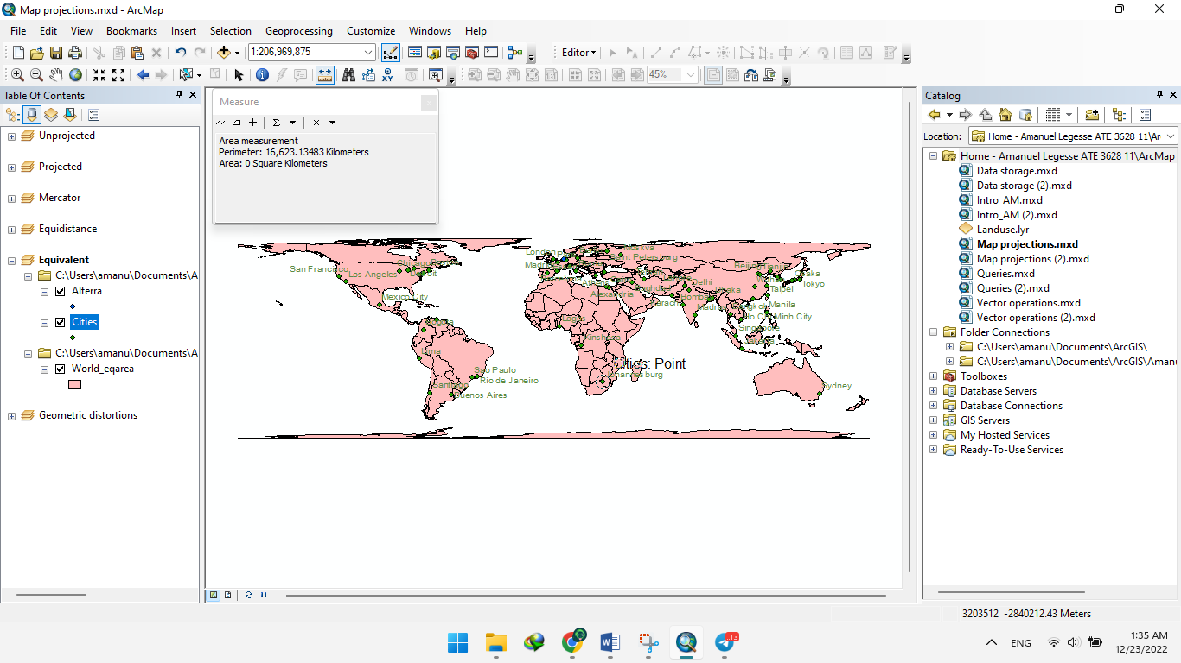

**Figure:** São Paulo – Jakarta (km)

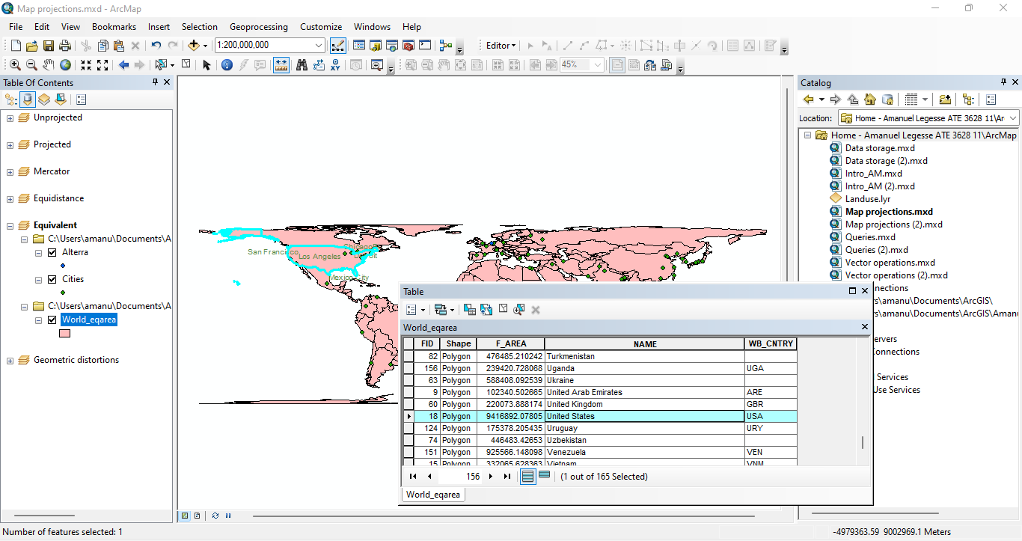

**Figure:** Area USA (km²)

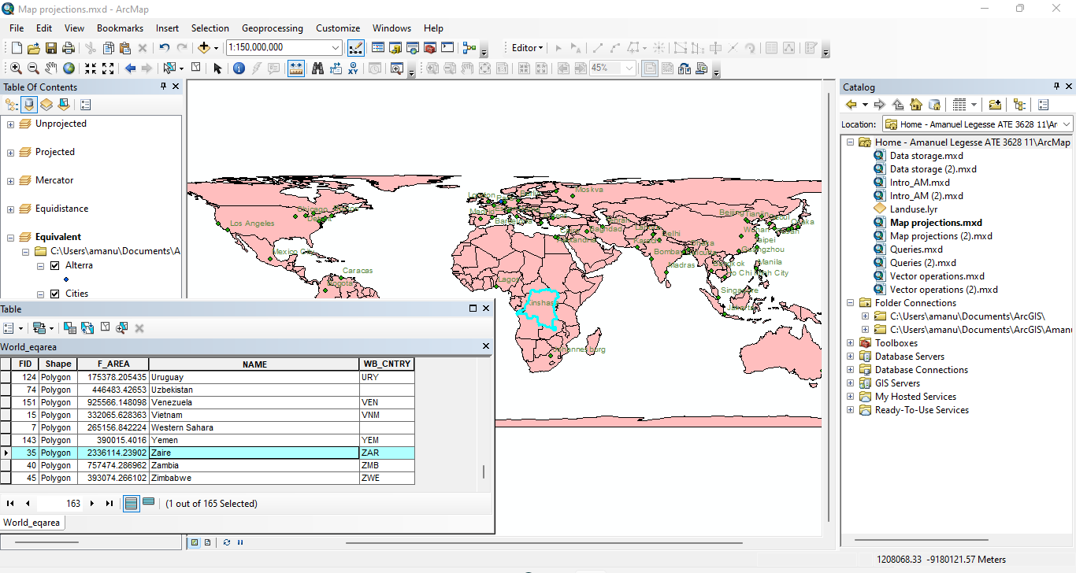

**Figure:** Area Dem. Rep. Congo (km²)

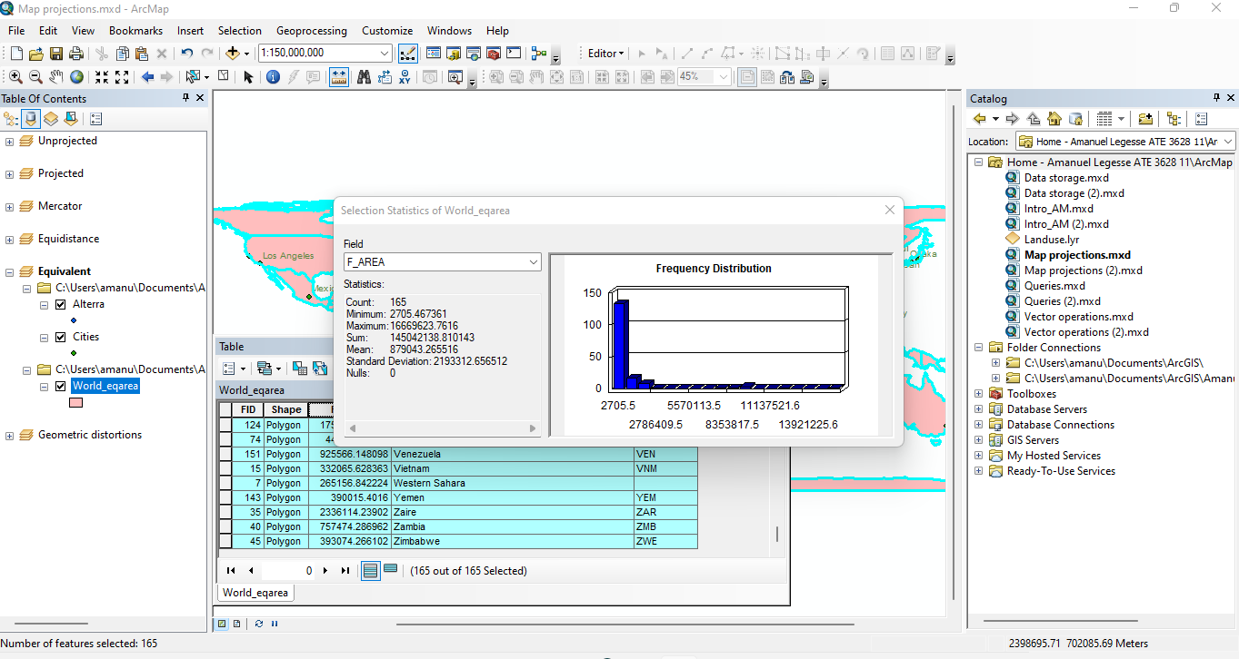

**Figure:** Area World (km²)

|  |  |  |  |  |
| --- | --- | --- | --- | --- |
|  | Mercator | Equidistant | Equivalent | Equivalent True dist./ area |
| Alterra – Johannesburg (km) | 10,078.480832 | 17,508.032125 | 16,379.312354 | 8,979 |
| São Paulo – Jakarta (km) | 17,190.127355 | 17,503.196928 | 16,623.13483 | 15,646 |
| Area USA (km² ) | 21518700.3426 | 6874895.91463 | 9416892.07805 | 9,631,418 |
| Area Dem. Rep. Congo (km² ) | 2355858.05155 | 1180772.88765 | 2336114.23902 | 2,345,410 |
| Area World (km² ) | 1009355323.875683 | 128579880.885469 | 145042138.810143 | 148,939,100 |

**Table:** Distance and area comparison using different projections